The impact of grid tariff design on energy communities
(4) Active end-user/prosumer participation
Daniel SCHWABENEDER⁽¹⁾, Georg LETTNER⁽¹⁾, Matthias MALDET⁽¹⁾, Frida REVHEIM⁽¹⁾
⁽¹⁾ TU Wien – Energy Economics Group

Motivation
Energy communities or local energy markets enable the exchange of electricity among community participants on a local level. Thus, prosumers can share excess local production with other end users that have simultaneous demand or flexibility options like batteries. However, grid tariffs pose a significant economic barrier for this local energy matching. There are regulatory attempts to mitigate these barriers, like e.g. the local grid tariff proposed in the EAG [1] by the Austrian government. For trades within an energy community this tariff only charges the cost for the involved grid levels.
Another tariff design option is a shift from volumetric grid tariff components to peak load pricing. This contribution analyses the economic effects of different tariff designs on energy community participants and the impact on the optimal operation of their flexibility options.
Methodology
Within the BEYOND [2] project measured data for the residual load of residential end users as well as municipality PV systems in the climate and energy model region Retz [3] participating in a local energy market have been gathered. This data together with various flexibility options for prosumers, like batteries or electric vehicles, are used to define a case study for an energy community as illustrated in Figure 1.
Next, the functionality of the simulation and optimization framework written in Julia and presented in [4] is extended to consider energy communities with different grid tariff components and design options. The framework simulates the optimal operation of multiple end users with different technology portfolios using a daily rolling horizon mixed-integer linear optimization approach. The optimization models minimize the total operational electricity procurement cost of all community members. Different approaches to consider annual or monthly peak load pricing tariffs in a rolling horizon optimization are compared.
Finally, different setups for grid tariff configurations are defined and the effects on the operational results are investigated. These include the impact on electricity procurement cost, trades within the community, self-consumption and peak loads at transformer substations.

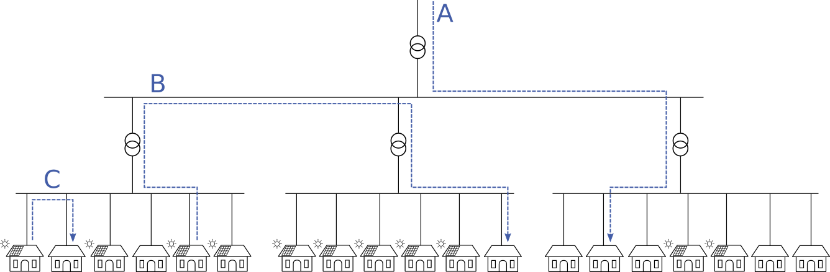

Figure 1: Overview of the community case study. With the local grid tariff proposed by the EAG external transactions like A are charged the regular grid tariff. For trades within the community like B end users pay a reduced tariff and for trades within the same low voltage grid branch like C the grid tariff is even lower.

Results and Conclusions
Preliminary results suggest that forming a community provides operational cost reductions of about 4% or 25 EUR per participant per year for the involved electricity consumers and prosumers. The introduction of a local grid tariff further improves this to around 6% or 36 EUR per participant per year.
Furthermore, the local grid tariff incentivizes energy community members to focus trades on a local level within the same low voltage grid branch. Figure 2 shows the aggregated cost components of all community members for three different setups.
Community setups with flexibility options in the technology portfolio tend to benefit less from forming energy communities and the introduction of local grid tariffs: The primary objective of batteries and other flexible technologies is to increase self-consumption at a consumer level. This results in less excess production that is traded among community members.
The analysis of peak load pricing in the grid tariff for energy communities is still work in progress. On the one hand, it is expected that this grid tariff design yields lower peaks both at individual grid connection points and at transformer substations. On the other hand, the change in incentives might result in lower levels of self-consumption for prosumers.

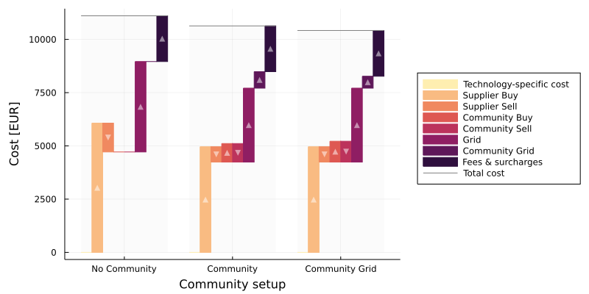
Figure 2: First results for a community consisting of 19 members without any flexibility options. The setup Community Grid represents a community with the local grid tariff.
Acknowledgement
This work is conducted within the BEYOND project which has received funding in the framework of the joint programming initiative ERA-Net Smart Energy Systems, with support from the European Union’s Horizon 2020 research and innovation programme and which is an associated project within Green Energy Lab.
Literature
[1] Federal Minister for Climate Action, Environment, Energy, Mobility, Innovation and Technology, Erneuerbaren-Ausbau-Gesetz (Renewable Expansion Law), 17 March 2021. [Online]. Available: https://www.bmk.gv.at/service/presse/gewessler/20210317_eag.html. [Accessed 25 May 2021].
[2] BEYOND, Blockchain-based electricity trading for the integration of national and decentralized local markets, ERA-Net Smart Energy Systems project. [Online]. Available: https://beyond-project.eu/ [Accessed 25 May 2021]
[3] Klima- und Energie-Modellregion (KEM) Retzer Land, [Online]. Available: https://www.unser-klima.at/. [Accessed 25 May 2021].
[4] Daniel Schwabeneder, Carlo Corinaldesi, Georg Lettner, Hans Auer, Business cases of aggregated flexibilities in multiple electricity markets in a European market design, Energy Conversion and Management, Volume 230, 2021, https://doi.org/10.1016/j.enconman.2020.113783.

Gußhausstraße 25-29/E370-3, +43-(0)1-58801-370375, schwabeneder@eeg.tuwien.ac.at, www.eeg.tuwien.ac.at

