Smart power-to-heat concepts for district heating system based on data-energy network
(2) Strom, Wärme-/Kälteerzeugung sowie Speicher
Shengjuan Wang⁽⁾, Alexander Wallis⁽¹⁾, Julia Straub⁽¹⁾, Sascha Hauke⁽¹⁾, Diana Hehenberger-Risse⁽¹⁾
⁽¹⁾ Landshut University of Applied Sciences

Motivation
Currently, under the topic of energy transition, power sector is still the focus of attention. However, heat is the largest energy end-use, accounting for more than 50 % of final energy consumption [1]. Therefore, energy transition without heat sector cannot be successful.
In Germany, fossil fuels such as natural gas and coal continue to dominate the energy supplies of district heating system (DHS) with a proportion of 70%, however, unlike electricity, renewable fuels such as various biomass meet only about 20 % [1]. This study proposes an intelligent power-to-heat (P2H) approach to realize an efficient and climate-friendly district heating supply.

Methodology
Gas heating is the most popular heating technology in Germany [2], because of its high efficiency, simple equipment, and low cost. To increase the share of renewable energy in transport and heating (buildings) sectors, Germany raises the price for CO2 emission to 25 euros per ton from 2021 [3].
This study analyzes the historical data of a district heating network and discusses the difficulty during the implementation of P2H concept from the economic, ecological and technological perspective. Ultimately, this study proposes a heat load forecasting model and a data-energy network for replacing gas heating with P2H.
Accurate load forecasting is crucial for network management tasks, not only for electricity consumption in power grids but also for heat demand in DHS [4]. Based on the forecast horizon, the method can be classified into short-term (hours till day), mid-term (days till weeks) and long-term (weeks till months) forecasting. Various Machine Learning (ML) models such as Support Vector Machines, Random Forests or Neural Networks, yield promising results for electricity demand [5] but can also be applied to heat load prediction [6]. In this study, day-ahead forecasting of heat load is used to reduce peak load by optimizing storage dimension and their operating strategies.

Results
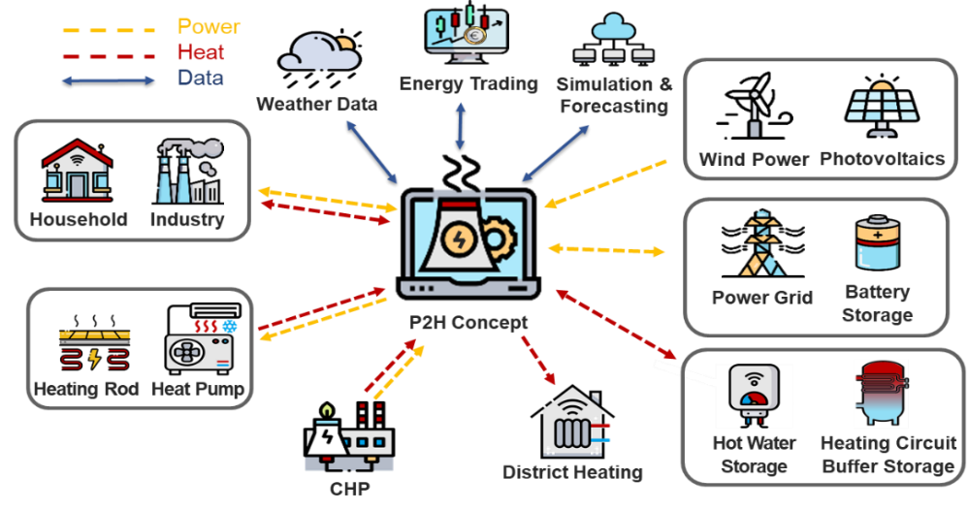
Replacing gas heating with P2H faces challenges in many aspects: first, electricity as a heating source is cost-effective and energy efficient only in a few cases, such as negative electricity prices or excessive renewable electricity generation. Second, different electro-thermal conversion technologies and different placing plans (centralized and decentralized) in P2H concept led to complex discussions about investment cost, installation difficulty and end-user acceptance. Third, the concept to improve the economy and energy efficiency of DHS by combining P2H and heat load forecasting remains to be verified. Based on the analysis results of the above questions, this study proposes a data-energy network to implement P2H concept in DHS, as shown in Figure 1. Considering the cost-effectiveness of the implementation, this study focuses on the interconnection of P2H with DHS in the supply of summer base load and winter peak load.
Figure 1: P2H concept including data and energy flows
In addition, this study presents a ML approach for heat load forecasting. Therefore, different models are trained and their prediction accuracy are compared. Based on this prediction, DHS operators are able to leverage storage systems and guarantee network stability and reliability.
In this context, the combination of P2H and ML approach takes the first step towards an efficient, climate-friendly district heating supply.

Literature
[1] Umweltbundesamt (UBA) (2021): Energieverbrauch für fossile und erneuerbare Wärme,
https://www.umweltbundesamt.de/daten/energie/energieverbrauch-fuer-fossile-erneuerbare-waerme#warmeverbrauch-und-erzeugung-nach-sektoren
[2] Bundesministerium für Wirtschaft und Energie (BMWi) (2020): Gesamtausgabe der Energiedaten, https://www.bmwi.de/Redaktion/DE/Binaer/Energiedaten/energiedaten-gesamt-xls.xlsx?__blob=publicationFile&v=133
[3] Bundesministerium für Umwelt, Naturschutz und nukleare Sicherheit (BMU) (2020): Fragen und Antworten zur Einführung der CO2-Bepreisung zum 1. Januar 2021, https://www.bmu.de/service/haeufige-fragen-faq/fragen-und-antworten-zur-einfuehrung-der-co2-bepreisung-zum-1-januar-2021/
[4] S. Idowu, S. Saguna, C. Åhlund, O. Schelén. “Applied machine learning: forecasting heat load in district heating system”, Energy Build, 133, pp. 478-488, 2016.
[5] A. Wallis, A. Haber, and S. Hauke. “Menschliches Wissen und Künstliche Intelligenz in einem Prognosemodell für Erneuerbare Energien”, In 16. Symposium Energieinnovation. IEE TU Graz, February 2020.
[6] S. Grosswindhager, A. Roither-Voigt, M. Kozek. “Online Short-Term Forecast of System Heat Load in District Heating Networks”, In proceedings of the 31st international symposium on forecasting, Prag, 2011.

Hochschule für angewandte Wissenschaften Landshut, Am Lurzenhof 1 84036 Landshut, Tel: +49 (0)871 - 506 656, diana.hehenberger-risse@haw-landshut.de, www.haw-landshut.de

