Are local energy and climate action plans aligned to national and EU climate targets? An assessment of 25 SEAP/SECAPs across 5 learning networks in 5 EU Countries
Local Climate Action
Giulia CONFORTO ⁽¹⁾, Marcus HUMMEL⁽¹⁾
⁽¹⁾e-think energy research

Motivation and research question

The transition to a sustainable energy system is endorsed at global scale and multiple level [1-4]. An example of multilevel-governance is the Covenant of Mayors (CoM) initiative, requiring its signatories to submit a Sustainable Energy Action Plan (SEAP/SECAP) [5-7]. However, it is not clear how solid and aligned to EU/national targets the SEAP/SECAPs are [8-15]. A selection of 25 action plans across 5 European networks of municipalities, is analysed trying to answer the research questions: “Do SEAPs/SECAPs contain elements helping their successful implementation?”, “Where do SEAPs/SECAPs show room for improvement?” and “Are local climate action plans aligned to national and European climate targets?”.

Methodology

The study proceeds in subsequent steps to identify the singularities of the selected municipalities, the strengths and weaknesses of their current energy and emission profiles, and the chances to successfully implement their action plans.

First, participating municipalities are compared based on structural and energy parameters (population, economy structure, employment, energy consumption and GHG emissions) to understand their distinctive features. Further insight is provided through data extracted from the Hotmaps Toolbox (building heating and cooling demand, renewable energy potentials). Climate targets for GHG emissions, renewable energy and energy efficiency, are collected at local, national and EU level.

Then, local targets are harmonized and compared to EU and national targets with the help of a 1990-base index of national emissions and energy consumption. Local emissions and consumption are back casted to the base year of EU and national targets (1990, 2005). Local targets are thus expressed in these baseline years and when misaligned, an estimation of how local targets should have been to be in line with national ones is calculated. Eventually, foreseen mitigation and adaptation actions listed in the action plans are categorized by scope and sector, to provide an overview of the most significant measures.

Results and conclusions

This in-depth assessment revealed a highly diversified landscape. Municipalities showed very different starting points, possibilities, strategies, and progress, and they produced substantially different plans. This alone confirms that no one-size-fits-all approach is suitable to local climate action.

Concerning the action plans, the CoM minimum requirements were generally met, but many of the additional recommended elements were overlooked. Data was sometimes old, incomplete, inconsistent, or had little detail. A comprehensive, far reaching, programmatic approach was often missing, focusing on targets for carbon emissions by 2020 or 2030. Elements recommended by the CoM and JRC [7, 16] such as renewables and efficiency targets, 2050 targets, RES potentials, sector targets e.g. building renovation rates, implementation steps, and a draft timeline were often missing. Measures that are more difficult to implement but produce greater impact [13, 17] such as regulation, standards, and financial tools, were greatly neglected, in favour of easier but less impactful actions such as municipal self-governing measures and awareness campaigns.

Already the fact that the municipalities developed such plans show a great motivation to advance the energy transition. However, local emissions targets were rarely aligned to national/EU targets: only 10 municipalities for 2020 targets, 4 for 2030 targets, and one for carbon neutrality. Renewable and efficiency targets were mostly missing. Estimated minimum targets in line with national ones were provided where local targets were missing.

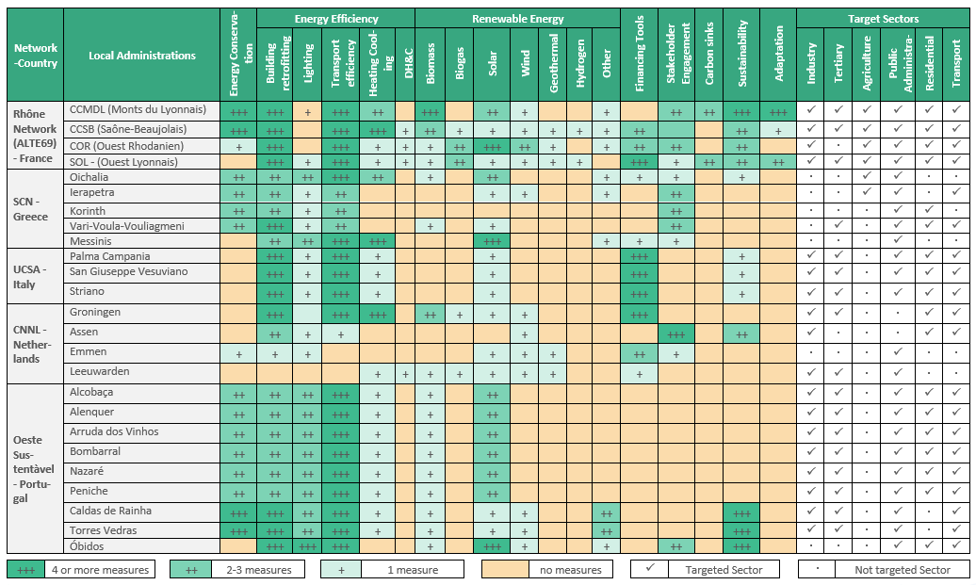
Figure 1: Categorization of SEAP/SECAPs Measures

Literatur
[1] Dobravec, V., Matak, N., Sakulin, C., Krajačić, G., 2021. Multilevel governance energy planning and policy: a view on local energy initiatives. Energy Sustain. Soc. 11, 2. https://doi.org/10.1186/s13705-020-00277-y
[2] Hoppe, T., Miedema, M., 2020. A Governance Approach to Regional Energy Transition: Meaning, Conceptualization and Practice. Sustainability 12, 915. https://doi.org/10.3390/su12030915
[3] Jänicke, M., 2017. The Multi-level System of Global Climate Governance – the Model and its Current State. Environ. Policy Gov. 27, 108–121. https://doi.org/10.1002/eet.1747
[4] Jänicke, M., Schreurs, M., Töpfer, K., 2015. The Potential of Multi-Level Global Climate Governance 12.
[5] Covenant of Mayors, 2021. About, Originis and Development [WWW Document]. URL https://www.covenantofmayors.eu/about/covenant-initiative/origins-and-development.html (accessed 3.5.21).
[6] Melica, G., Bertoldi, P., Kona, A., Iancu, A., Rivas, S., Zancanella, P., 2018. Multilevel governance of sustainable energy policies: The role of regions and provinces to support the participation of small local authorities in the Covenant of Mayors. Sustain. Cities Soc. 39, 729–739. https://doi.org/10.1016/j.scs.2018.01.013
[7] EU Institute for Energy and Transport - JRC (Joint Research Centre), 2010. Guidebook “How to Develop a Sustainable Energy Action Plan (SEAP)” [WWW Document]. EU Sci. Hub - Eur. Comm. URL https://ec.europa.eu/jrc/en/publication/eur-scientific-and-technical-research-reports/guidebook-how-develop-sustainable-energy-action-plan-seap (accessed 3.5.21).
[8] Croci, E., Lucchitta, B., Janssens-Maenhout, G., Martelli, S., Molteni, T., 2017. Urban CO2 mitigation strategies under the Covenant of Mayors: An assessment of 124 European cities. J. Clean. Prod., Experimentation for climate change solutions 169, 161–177. https://doi.org/10.1016/j.jclepro.2017.05.165
[9] Grafakos, S., Viero, G., Reckien, D., Trigg, K., Viguie, V., Sudmant, A., Graves, C., Foley, A., Heidrich, O., Mirailles, J.M., Carter, J., Chang, L.H., Nador, C., Liseri, M., Chelleri, L., Orru, H., Orru, K., Aelenei, R., Bilska, A., Pfeiffer, B., Lepetit, Q., Church, J.M., Landauer, M., Gouldson, A., Dawson, R., 2020. Integration of mitigation and adaptation in urban climate change action plans in Europe: A systematic assessment. Renew. Sustain. Energy Rev. 121, 109623. https://doi.org/10.1016/j.rser.2019.109623
[10] Kona, A., Bertoldi, P., Monforti-Ferrario, F., Rivas, S., Dallemand, J.F., 2018. Covenant of mayors signatories leading the way towards 1.5 degree global warming pathway. Sustain. Cities Soc. 41, 568–575. https://doi.org/10.1016/j.scs.2018.05.017
[11] Messori, G., Brocchieri, F., Morello, E., Ozgen, S., Caserini, S., 2020. A climate mitigation action index at the local scale: Methodology and case study. J. Environ. Manage. 260, 110024. https://doi.org/10.1016/j.jenvman.2019.110024
[12] Pablo-Romero, M. del P., Pozo-Barajas, R., Sánchez-Braza, A., 2018. Analyzing the effects of the benchmark local initiatives of Covenant of Mayors signatories. J. Clean. Prod. 176, 159–174. https://doi.org/10.1016/j.jclepro.2017.12.124
[13] Palermo, V., Bertoldi, P., Apostolou, M., Kona, A., Rivas, S., 2020. Assessment of climate change mitigation policies in 315 cities in the Covenant of Mayors initiative. Sustain. Cities Soc. 60, 102258. https://doi.org/10.1016/j.scs.2020.102258
[14] Salvia, M., Reckien, D., Pietrapertosa, F., Eckersley, P., Spyridaki, N.-A., Krook-Riekkola, A., Olazabal, M., De Gregorio Hurtado, S., Simoes, S.G., Geneletti, D., Viguié, V., Fokaides, P.A., Ioannou, B.I., Flamos, A., Csete, M.S., Buzasi, A., Orru, H., de Boer, C., Foley, A., Rižnar, K., Matosović, M., Balzan, M.V., Smigaj, M., Baštáková, V., Streberova, E., Šel, N.B., Coste, L., Tardieu, L., Altenburg, C., Lorencová, E.K., Orru, K., Wejs, A., Feliu, E., Church, J.M., Grafakos, S., Vasilie, S., Paspaldzhiev, I., Heidrich, O., 2021. Will climate mitigation ambitions lead to carbon neutrality? An analysis of the local-level plans of 327 cities in the EU. Renew. Sustain. Energy Rev. 135, 110253. https://doi.org/10.1016/j.rser.2020.110253
[15] Schoenberger, P., 2013. Municipalities as Key Actors of German Renewable Energy Governance: An Analysis of Opportunities, Obstacles, and Multi-Level Influences 39.
[16] EU Institute for Energy and Transport - JRC (Joint Research Centre), 2018. Guidebook “How to Develop a Sustainable Energy and Climate Action Plan (SECAP)” Andreanidou, K., Bertoldi, P., and others [WWW Document in 3 parts]. EU Sci. Hub - Eur. Comm. URL https://publications.jrc.ec.europa.eu/repository/handle/JRC112986
[17] Romero-Lankao, P., Burch, S., Hughes, S., Auty, K., Aylett, A., Krellenberg, K., Nakano, R., Simon, D., and Ziervogel, G. (2018). Governance and policy. In Rosenzweig, C., W. Solecki, P. Romero-Lankao, S. Mehrotra, S. Dhakal, and S. Ali Ibrahim (eds.), Climate Change and Cities: Second Assessment Report of the Urban Climate Change Research Network. Cambridge University Press. New York 585–606 https://doi-org.uaccess.univie.ac.at/10.1017/9781316563878.023

